Exam 1 - Study Guide

1. Fill in the blanks with what Python would display.

|  |
| --- |
| **def** print_moar(stuff):  i = 0  while stuff and i < 2:  stuff = print(stuff, print('colin'))  i += 1  **return** stuff  >>> chris = print_moar('josh')  >>> chris |

2. Consider the following function definition:

|  |
| --- |
| **def** square(x):  return x * x  **def** argentina(n):  print(n)  if n > 0:  **return** lambda k: k(n+1)  else:  **return** 1 / n |

After executing the above code, what will Python display when evaluating each of the following expressions?

>>> print(1, print(2))

>>> argentina(0)

>>> argentina(1)(square)

3. Draw the environment diagram that results from running the following code.

|  |
| --- |
| **def** yak(zebra):  **return** 20 // zebra  **def** llama(alpaca):  zebra = 0  **def** yak(zebra):  **return** alpaca(zebra)  **return** yak  llama(yak)(4) |

4. Write a function, make_digit_remover, which takes in an integer from 0-9, i. It returns another function which takes in an integer, and removes all digits from right to left up to and including the first occurrence of i. If i does not occur in the integer, this function returns the original number.

|  |
| --- |
| def make_digit_remover(i):  """  >>> remove_two = make_digit_remover(2)  >>> remove_two(232018)  23  >>> remove_two(23)  0  >>> remove_two(99)  99  """  def remove( ): |

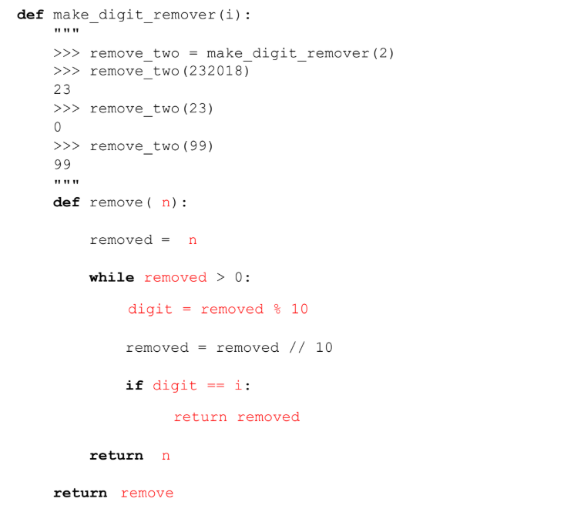

Midterm 2 Practice

Question 1: WWPD?

|  |
| --- |
| >>> L = [1, 2, 3, 4]  >>> L[0]  1  >>> L[100]  Error  >>> L[-1]  4  >>> L[2] = 100  >>> L  [1,2,100,4] |

Question 2: Implement a function map_mut that takes a list as an argument and maps a function f onto each element of the list. You should mutate the original lists, without creating any new lists. Do NOT return anything.

|  |
| --- |
| **def** **map_mut**(f, L):  """Mutatively maps f onto each element in L.  >>> L = [1, 2, 3, 4]  >>> map_mut(lambda x: x**2, L)  >>> L  [1, 4, 9, 16]  """  "*** YOUR CODE HERE ***" |

Solutions

**Question 2:**

**def** **map_mut**(f, L):

**for** i **in** range(len(L)):

L[i] = f(L[i])